Physical Education Handbook | School Year  2019-20
The Pioneer Junior High Handbook includes policy statements, forms, grading standards and goals. Please refer to this handbook whenever your child is absent, has upcoming fitness testing or does not understand operating procedures for the locker room. |  | Pioneer Junior High School
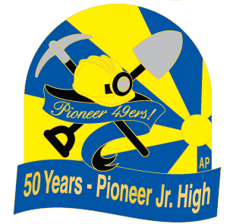

PHYSICAL EDUCATION GOALS

A WELL-PLANNED, WELL-IMPLEMENTED PHYSICAL EDUCATION PROGRAM WILL FOSTER THE FOLLOWING BENEFITS:

- IMPROVED PHYSICAL FITNESS: areas include muscular strength, flexibility, muscular endurance, body composition, and cardiovascular endurance.
- SELF-DISCIPLINE: develops student responsibility for health and fitness.
- SKILL DEVELOPMENT: develops motor skills of balance, agility, reaction time, speed, and coordination.
- EXPERIENCE SETTING GOALS: gives students the opportunity to set and strive for personal, achievable goals.
- IMPROVED JUDGMENT: provides students with opportunities to assume leadership, cooperate with others, and accept responsibility for their own behavior.
- IMPROVED SELF-CONFIDENCE AND SELF-ESTEEM: helps students become more confident, assertive, independent, and self-controlled.
- STRESS REDUCTION: provides an outlet for releasing tension and anxiety.
- STRENGTHENS PEER RELATIONSHIPS: helps students socialize with others more successfully.
- REINFORCES KNOWLEDGE LEARNED IN OTHER SUBJECT AREAS: serves as lab for application of content from science, math, and social studies courses.

The Physical Education Framework for California Public Schools is the key resource for developing quality physical education programs. At PJH we follow a sequential, developmental, age-appropriate program designed to provide students with knowledge and ability needed to maintain active, healthy lifestyles. In accordance with the framework, the three major goals for the curriculum are:
- MOVEMENT SKILLS AND KNOWLEDGE
- SELF-IMAGE AND PERSONAL DEVELOPMENT
- SOCIAL DEVELOPMENT

There are also established national and state standards for physical education that address skills and knowledge students should have at particular grade levels. Each standard includes grade-level indicators that provide examples of what students should know and be able to do to meet the standard.

The California Education Code also mandates that students in grades 7-8 shall have 400 minutes of physical education each 10 days. The intent of these mandates is to ensure that physical education is an integral part of the educational program for all students.

Federal Title IX regulations require that all physical education courses be coeducational. Students are not to be separated based on gender.
PJH PHYSICAL EDUCATION UNIFORM POLICY

AN INTEGRAL PART OF THE PJH PHYSICAL EDUCATION PHILOSOPHY IS THAT ALL STUDENTS DRESS-OUT EACH AND EVERY DAY IN THE PE UNIFORM. THIS INCLUDES RAINY DAYS AND WHEN ON A MEDICAL. THE REQUIRED DAILY WEAR IS TO INCLUDE:
- REQUIRED PE CLOTHES – solid royal blue, nylon mesh shorts w/drawstring, reversible royal blue/gold t-shirt or a solid royal blue and solid gold t-shirt. Available at PJH for $26 or you may purchase elsewhere. If you purchase elsewhere, they must meet the above requirements.
- The only markings allowed on the uniform are the first and last name of the owner. No decorating is to be done
- Uniforms need to fit appropriately. Allow room for growth
- Shirt must be tucked into the shorts. Shorts are to ride at the waist above the hip – no “sagging” and no underwear showing
- Athletic socks that are clearly above the ankle and visible to the teacher (keep an extra pair in PE locker)
- Athletic shoes in good condition with laces secured on top of the shoe (preferable to have a pair only for PE)
- Jewelry removed and secured in the PE locker in a container – this includes all earrings (except studs), watches, bracelets, ankle bracelets, necklaces, rings, wristbands, and any piercings that could be a safety hazard
- Hair tied back securely if shoulder-length or longer
- Regulation pioneer hats may be worn in PE class
- Clothes worn to school may not be worn under the PE uniform
- Sweatshirts and sweatpants may be worn over the regular uniform during cold weather. Sweats may be of any color. JACKETS OR SWEATERS ARE NOT ALLOWED.
- The uniform is to be taken home the last day of the week to be laundered and returned to school the first day of the week for clean clothes check
- If the uniform is missing, a set of loan clothes will be issued. Students will check-out the loaners from the PE office at the start of class and return them at the end (the PE staff will be responsible for the cleaning of the loan clothes)
- Each student is required to wear only their own PE clothes and not “borrow” from someone.

LOCKER ROOM RULES

- All students will be issued a locker that is to be used to store the physical education uniform and any other essentials. Everyone is required to use a PE locker during the class period.
- All students will be issued a Pioneer combination lock and must be returned at the end of the school year in same condition or there will be a replacement cost.
- Under no circumstances is any student to share lockers with anyone or give any other student their combination. The school is not responsible for lost belongings. It is up to the student to check that their locker is secured before they leave the dressing room and that all items are safely stored in the locker
- All backpacks/tote bags must fit in their PE locker.
- No food or drink is allowed in the locker room (water bottles are an exception)
- Glass and/or aerosol products are not allowed
- All products used in the locker room need to be fragrance-free for the health and safety of students with allergies or asthma. Stick deodorant, unscented lotion, hand sanitizer and sunscreen are allowed. Hair spray, perfume, body spray, scented body lotion and scented hand sanitizer are not allowed at school or the locker room. These items will be confiscated, and disciplinary action will be followed according to school policy.
- Students need to bring supplies to keep in their locker i.e. band-aids, hair ties, safety pins, kleenex, and other personal necessities
- A jewelry container is a must, since jewelry can fall down into other lockers if not secured

SAFETY

- Behavior that might lead to injury to self or others will not be allowed

- Report any injury immediately to your teacher. Do not move a student with an injury

- Report any equipment or ground conditions that may be dangerous

- Do not go yourself or take any other student to the health office or locker room without teacher permission

- Modified activities when raining, extreme heat or poor air quality. We go inside for rain, we are outside if misty or light drizzle. During extreme heat, we limit or modify activity depending on time of day. This may include no push-ups, bars or running. For poor air quality, we follow the AQMD guidelines for our area and activities are modified or taken inside according to the alert level.

OBSTACLE COURSE

- All students participate in the obstacle course every day at the beginning of the period before roll and exercises. This is part of the physical education grade
- It is each student’s responsibility to complete the course and be seated on their roll call number by the tardy bell
- The course includes bars, pole, and warm-up run
- Each student is to check-in at the completion of the course with the teacher’s assistant (TA). If no T.A. is there, the students are to line-up single file at the cone designated for their class and wait

GRADE POLICY
THE PHYSICAL EDUCATION DEPARTMENT HAS STANDARDIZED AREAS OF GRADING WHICH INCLUDE:

- Authentic skill assessment of fitness based on performance standards
- Team and individual assessment
- Responsibility areas
- Participation and cooperation

Each teacher has developed a grading system within this framework. All questions will need to be directed to the individual teacher for specifics.

PARTICIPATION

IN ORDER TO PARTICIPATE IN GAME PLAY, EACH STUDENT MUST MEET THE FOLLOWING CRITERIA:
- Complete the obstacle course correctly
- Be seated on the roll number before the bell rings (no tardies)
- Wear their own correct uniform including visible, athletic socks
- No jewelry
- Hair pulled back if longer than shoulder-length
- Shirt tucked-in and shorts at the hips

CONSEQUENCES:
- Loss of participation points for the day
- Habitual misconduct or not meeting class expectations will result in detention, parent contact and/or office referral.

MEDICAL EXCUSES
All notes (parent/doctor) are to be given to the health office before school to be kept on file.

PARENT/GUARDIAN NOTE:
PARENT NOTES WILL BE ACCEPTED FOR LIMITED OR FULL RESTRICTION FROM ACTIVITIES FOR UP TO THREE CONSECUTIVE DAYS (WEEKENDS COUNT AS PART OF THE THREE CONSECUTIVE DAYS). THE NOTE MUST INCLUDE THE FOLLOWING OR IT WILL NOT BE ACCEPTED:
- Date
- Student’s full name
- Reason for the excuse (please be specific)
- Length of the restriction (1,2, or 3 days) – if not specific, the note will be for 1 day only
- Designate if full or limited restriction (see below for clarification)
- Phone number where parent can be reached
- Signature (only a parent or guardian may write a note)

LIMITED RESTRICTION INCLUDES:
- Dress – out
- Walk obstacle course
- Stretch
- Light activity
- No make-up work required for participation points

FULL RESTRICTION INCLUDES:
- Dress-out
- Observe during class
- Make-up work required

HEALTH TECH WILL NOT WRITE A PE EXCUSE FOR A STUDENT.

DOCTOR NOTE:

WHEN A STUDENT IS TO BE EXCUSED FOR A PERIOD LONGER THAN THREE DAYS, A DOCTOR’S NOTE MUST BE OBTAINED AND INCLUDE THE FOLLOWING:

- Length of restriction – Must have a beginning and ending date
- Specific activity the student cannot perform
- Any dressing restrictions

THE TEACHER WILL DETERMINE ONE OF THE FOLLOWING OPTIONS FOR THE STUDENT:

- The student will continue in class with modifications
- The student will perform as a class TA. and earn full credit
- The student will be assigned to the library with specific assignments that will be completed and turned-in for the grade

A DOCTOR NOTE IS REQUIRED FOR ANY ON-GOING MEDICAL PROBLEM THAT MAY RESTRICT PARTICIPATION IN CLASS AT ANY TIME.

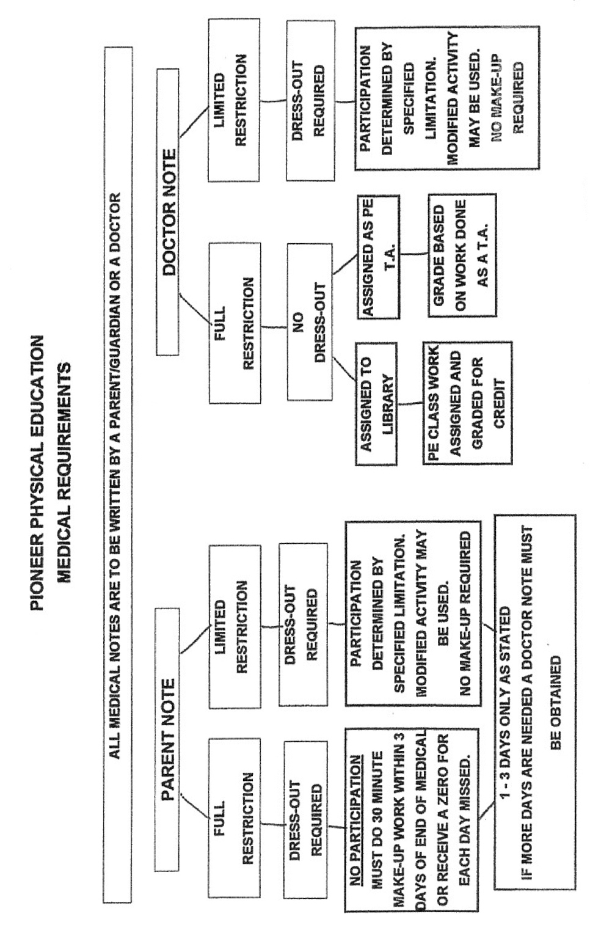
PHYSICAL EDUCATION MAKE-UP WORK

NAME: _______________________________________ DATES OF ABSENCE: __________

TEACHER: _____________________________ PERIOD: __________

YOU MUST DO 30 MINUTES OF PHYSICAL ACTIVITY FOR EVERY DAY YOU ARE ABSENT. YOU HAVE 3 DAYS FROM THE ABSENCE TO TURN IN FOR CREDIT.

1. DESCRIBE THE ACTIVITY IN DETAIL.

2. HOW LONG DID YOU DO EACH ACTIVITY OR EXERCISE?

3. EXPLAIN WHAT BENEFITS YOU FELT YOU RECEIVED FROM THIS ACTIVITY.

PARENT SIGNATURE_______________________________________________

THIS IS THE FORM THAT IS USED IF A STUDENT IS ABSENT, ON A FULL MEDICAL, OR MISSED CLASS FOR ANY OTHER REASON.

- The only way to earn the full daily credit is to do the make-up work with-in the time frame of 3 days.

- It is the responsibility of the student to get the make-up sheet off the clip on the back door of the girl’s equipment room or on school loop in your teacher’s locker and to complete the 30 minutes of activity for each day missed.

- No work will be accepted without parent signature.

- Any acceptable physical activity can be used to qualify for make-up.

440 YARD RUN | MILE 7TH GRADE | BARS
1:18 AND UNDER A+ | BOYS | A - STRAIGHT BODY
1:19 - 1:28 A | UNDER 7:11 A | B - SOME SWINGING
1:29 - 1:40 B | 7:12 - 8:40 B | C - KICKING ACROSS
1:41 - 1:51 C | 8:41 - 10:00 C | D - HALFWAY
1:52 - 2:02 D | 10:01 - 12:00 D | F - NOT AT ALL
2:03 AND OVER F | 12:01 + F
FENCE LAP | GIRLS | PULL-UPS
2:10 AND UNDER A+ | UNDER 8:23 A | Boys
2:11 - 2:30 A | 8:24 - 10:00 B | A = 7
2:31 - 2:50 B | 10:01 - 11:05 C | B = 4
2:51 - 3:15 C | 11:06 - 12:00 D | C =2
3:16 - 3:30 D | 12:01 + F | D = 1
3:31 AND OVER F
 |  | Girls
880 YARD RUN | PUSH-UPS | A = 2
3:10 AND UNDER A+ | BOYS | B = 1
3:11 - 3:25 A | 45+ A+
3:26 - 3:45 B | 40 - 44 A | WALL
3:46 - 4:15 C | 30 - 39 B | BIG WALL - A
4:16 - 4:35 D | 24 - 29 C | SMALL WALL - B
4:36 AND OVER F | 15 - 23 D | NONE - F
 | 14 - 0 F
MILE 8TH GRADE
BOYS | GIRLS | POLE
UNDER 7:00 A | 25+ A+ | TO THE TOP - A
7:01 - 8:15 B | 21 - 24 A | 3/4 - B
8:16 - 10:00 C | 15 - 20 B | 1/2 - C
10:01 - 12:00 D | - - 14 C | 1/4 - D
12:01 + F | 7- 10 D | NOT AT ALL - F
 | 6- 0 F
GIRLS |  | CURLS
UNDER 8:15 A |  | 55+ A+
8:16 - 9:30 B |  | 48 - 54 A
9:31 - 10:23 C |  | 41 - 47 B
10:24 - 12:00 D |  | 35 - 40 C
12:01 + F |  | 30 - 34 D
 |  | 29 AND UNDER F
Fitness Standards

Presidential Fitness Award
(85th Percentile Nationally)
Boys 11 12 13 14
Curl –ups 47 50 53 56
Sit & Reach 31cm 31 cm 33 cm 36 cm
Shuttle Run 10 sec. 9.8 sec. 9.5 sec. 9.1 sec.
Mile Run 7:32 7:11 6:50 6:26
Push-ups 27 31 39 40
Pull ups 6 7 7 10

Girls 11 12 13 14
Curl –ups 42 45 46 47
Sit & Reach 34 cm 36 cm 38 cm 40 cm
Shuttle Run 10.5 sec. 10.4 sec. 10.2 sec. 10.1 sec.
Mile Run 9:02 8:23 8:13 7:59
Push-ups 19 20 21 20
Pull ups 3 2 2 2

National Fitness Award
(50th Percentile Nationally)
Boys 11 12 13 14
Curl –ups 37 40 42 45
Sit & Reach 25 cm 26 cm 26 cm 28 cm
Shuttle Run 11.1 sec. 10.6 sec. 10.2 sec. 9.9 sec.
Mile Run 9:20 8:40 8:06 7:44
Push-ups 15 18 24 24
Pull ups 2 2 3 5

Girls 11 12 13 14
Curl –ups 32 35 37 37
Sit & Reach 29 cm 30 cm 31 cm 33 cm
Shuttle Run 11.5 sec. 11.3 sec. 11.1 sec. 11.2 sec.
Mile Run 11:17 11:05 10:23 10:06
Push-ups 11 10 11 10
Pull ups 1 1 1 1

